

|  |  |
| --- | --- |
| **Student Name/ID Number:** | Syukur Sidiq Nur Alam / BDSE07-0922-089 |
| **Academic Year:** | 2023 |
| **Unit Assessor:** | Ei Thandar Khaing |
| **Project Title:** | Power BI Data Preparation and Data Transformation |
| **Issue Date:** | 25-Nov-2023 |
| **Submission Date:** |  |

|  |
| --- |
| **Learner declaration** |
| I certify that the work submitted for this assignment is my own and research sources are fully acknowledged.  Student signature: Date: |

**Assignment 5:**

1. Load the dataset

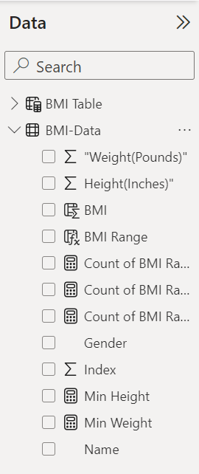

2. Create a new column to calculate the body mass index (BMI) for each individual in the dataset.

• In the "Fields" pane, select the "Data" table and go to the "Modeling" tab.

• Select "New Column" and enter the formula "BMI = [Weight]/POWER([Height]/100,2)".

• Click "OK" to create the new column.

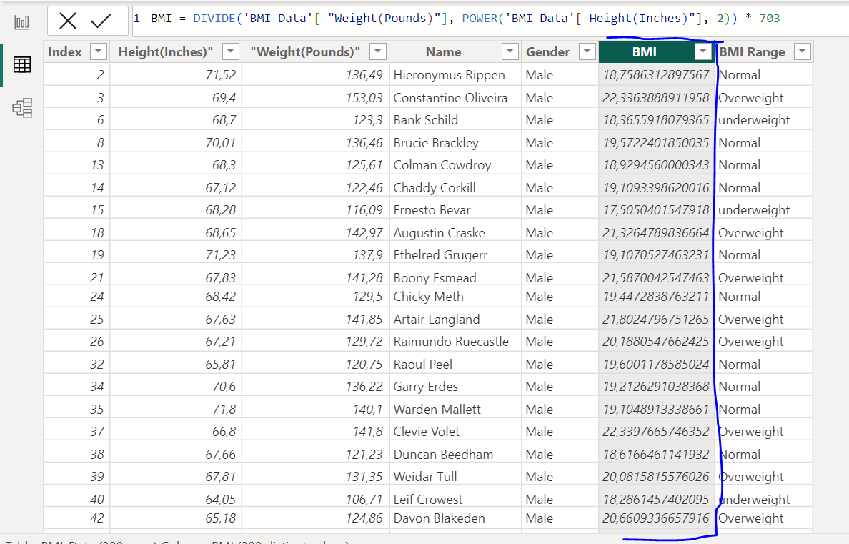

3. Create a pivot table to display the average height and weight by gender.

• In the "Fields" pane, select the "Data" table and drag the "Gender" field to the "Rows" area and the "Height" and "Weight" fields to the "Values" area.

• Select "Average" for both "Height" and "Weight" fields.

• The pivot table will display the average height and weight by gender.

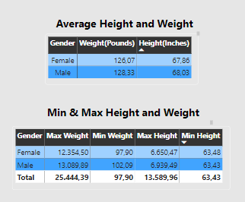

4. Create a chart to display the distribution of BMI in the dataset.

• In the "Fields" pane, select the "Data" table and drag the "BMI" field to the "Values" area

of a new visual.

• Choose a chart type (e.g., histogram) and customize the chart as needed.

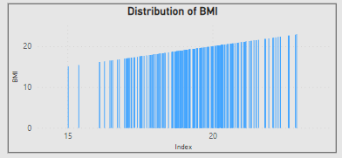

5. Use conditional formatting to highlight the individuals with a BMI over 30.

• In the "Fields" pane, select the "Data" table and drag the "BMI" field to the "Values" area

of a new visual.

• Go to the "Format" tab and select "Conditional formatting".

• Choose "Color scale" and set the minimum and maximum values to the appropriate

values.

• Set the color scale for values above 30 to a different color.

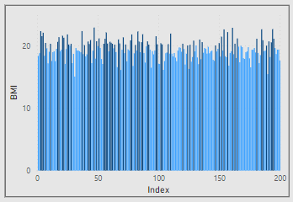

6. Create a new sheet to display the summary of the data, including the average height and weight, the maximum and minimum height and weight, and the number of individuals in the dataset.

• Go to the "Report" tab and select "New Page".

• Add a new visual and drag the "Height" and "Weight" fields to the "Values" area.

• In the "Fields" pane, select the "Data" table and go to the "Modeling" tab.

• Select "New Measure" and enter the formula "Average Height = AVERAGE(Data[Height])".

• Repeat the same steps for the "Average Weight", "Maximum Height", "Minimum Height", "Maximum Weight", "Minimum Weight", and "Number of Individuals" measures.

• Add the measures to the visual and customize as needed.

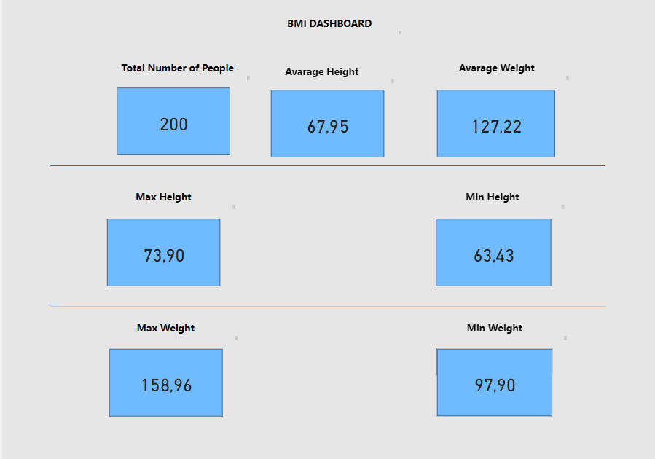

7. Create a calculated column to categorize the individuals in the dataset by BMI range (e.g., underweight, normal, overweight, obese).

• In the "Fields" pane, select the "Data" table and go to the "Modeling" tab.

• Select "New Column" and enter the formula "BMI Range = IF([BMI] < 18.5, 'Underweight', IF([BMI] < 25, 'Normal', IF([BMI] < 30, 'Overweight', 'Obese')))".

• Click "OK" to create the new column.

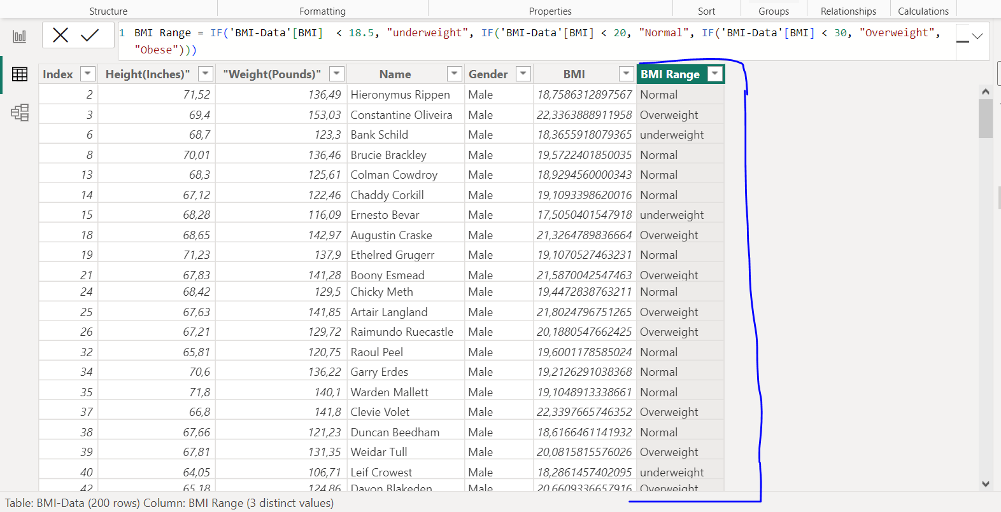

8. Filter the pivot table to show only the individuals with a BMI over 30.

• In the "Fields" pane, select the "Data"9. Create a new table to show the top 10 individuals with the highest BMI, including their name, gender, height, weight, and BMI.

• In the "Fields" pane, select the "Data" table and go to the "Modeling" tab.

• Select "New Table" and enter the formula "Top 10 BMI = TOPN(10, Data, [BMI])".

• Click "OK" to create the new table.

• Add the "Name", "Gender", "Height", "Weight", and "BMI" fields to the new table.

